**Digital Marketing Practices**

**Assessment 1: Individual report including design element**

Introduction 1

Abstract 1

Consistency and Commitment 1

The Liking Principle 2

Authority 3

Scarcity 4

Social validation or proof 4

Reciprocity 5

Legal and Ethical Issues 6

REFENCES 6

# Introduction

This report is about a hypothetical Software Company, ELS Software Solutions that offers various solutions in the technological ecosystem such as developing website application, mobile applications and website applications. The company also offers consultancy services based on the various services related to technology

The company has been branded by a popular digital marketing company and follows the Cialdini principle of persuasion to achieve success and gain traction in the technology ecosystem by establishing a much broader client base. The website is available at <https://journey-map.vercel.app/>.

# Abstract

In this report, we analyse the various functionalities of the component of the application layout design using the 6Cialdini principles of persuasion. The application is a single page static web application that contains useful information of ELS software development company. The company has been branded and digitally marketed and primarily is in the business of making a building software application.

## Consistency and Commitment

The website has a comment section of the different clients that have successfully given positive feedback about the companies products and services. All these are clients that have a positive feedback on the benefits of using the companies services in branding their businesses.

The website also has a contacts page where users can enter their particular email addresses. This also allows for subscription functionality where the users will constantly receive email address concerning the particular offers that the company is giving. This includes discounted prices or offers during days like Monday or festive seasons, holidays.

The users can also receive email address concerning new designs and features that have been released. The emails can also be that of news that features the company in social media such as twitter, Facebook, or Instagram. This will significantly help the users to be updated regularly about the company's activities in a consistent manner.

The social media links of the company in the footer section makes it possible for potential and existing clients to put tabs on the company and its activities in a more digitised manner. This follows that all the information concerning the company cannot be represented on the website pages. Information that scatters on the web can be more meaningful and important to a user as well. A client can follow the company on this social media platform as well and see all the posts that are made by the company on related and meaningful information as well.

Figure 1

## The Liking Principle

Humans are easily persuaded by the products or services that they like or that they well identify with. The product or service acquired by an individual is supposed to make them feel in a *certain* way, that is why they acquire it. People are more attracted to buy or purchase good services or products, that is, what they like or interested in. A product or service can largely be influenced by social media through the review section and comment section.

The company has a well-established platform on social media. Clients that comment on the company's page on relevant posts are likely to recommend the company and its services to friends and other people that are within their ecosystem. This boosts the company’s influence in the field of software development and hence improving the client base. This also has a major influence in a client in making critical and important decisions of whether to choose the company to develop its software applications.

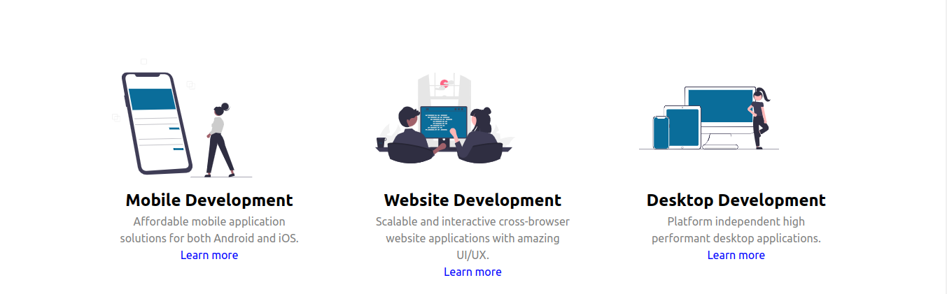Figure 2

## Authority

Authority is the credibility or knowledge base of a certain product or service in its domain of existence. This is the major building block of trust. A clients trust to a certain product is what makes them more likely to buy or interact with it. To establish authority and credibility, we shall go with *Software Solutions* and *Brand.*

The company website also has a terms and conditions section applied. This easily makes the client know that the operation and action of the company are within a specified lot of operation. This highly enables the company to market itself and resolve its legitimacy to the clients. Various client rights like using of their personalized information will be liable to legal action.

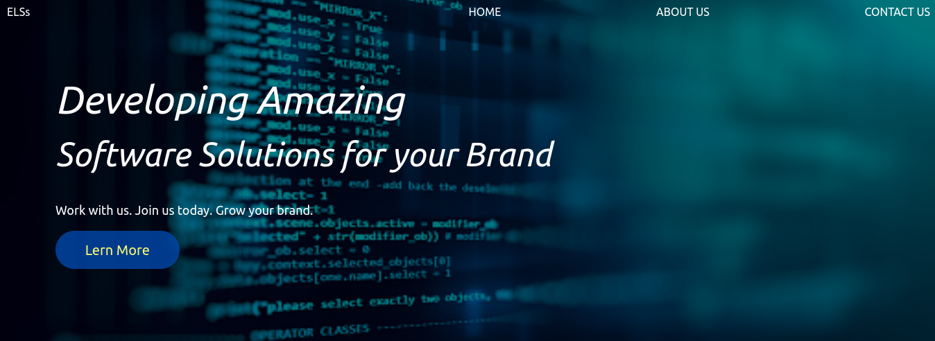

Figure 3

## Scarcity

Scarcity means that the less something is, the more many people will purchase it. Scarce things are viewed as of value or quality to a lot of people, that is why they are scarce. The scarcity principle is always a matter of perception. In this application, scarcity can be viewed as subscription discount to clients who take membership actions over a specified time. This can include clients who have been referred to by other clients. These particular clients are of particular interest because they are offered with discounted prices for every service that the company provides.

Creating scarcity about the services and products offered significantly boosts the client base overtime and the client response initiating them to make approach and inquiries on these particular workdays about the various products and solutions that they can be offered with.

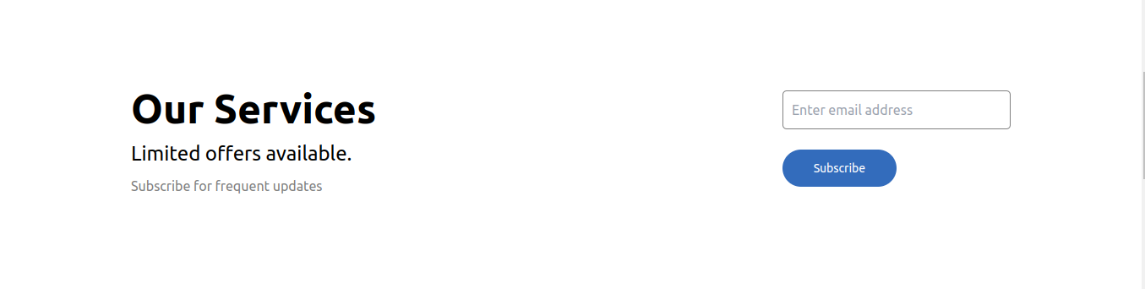

Figure 3

## Social validation or proof

Despite a company’s website or portfolio, people will always what to know how many people are using a company’s product or service. The social media or a social community together with their opinions largely influence a person's decision to purchase a certain product. Advertisement is also a key part in spreading awareness.

Social validation also referred to as social proof or consensus influences people based on the social norm. To achieve social proof, the website application has various links to social media sites such as LinkedIn, twitter, Facebook and Instagram where it manages its brand and reputation. They are the links that contain various comments and suggestions about the company's efficiency in providing the design and developing of website application.

The website also has a section that has various brands that have used the various utilities that the company offers and provides. An image, a name and a comment are attached to every client that has used the company's services and product in their day-to-day Liking operations. The company has also been featured by successful brands that it has helped in developing and in the digital marketing ecosystem.

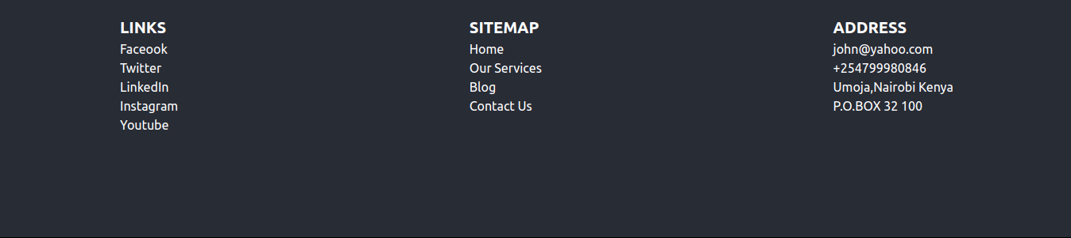Figure 4

## Reciprocity

Reciprocity is about returning favours to people. This can be affected through offering of discount prices and coupons. We can achieve this by issue of referral codes and coupons.

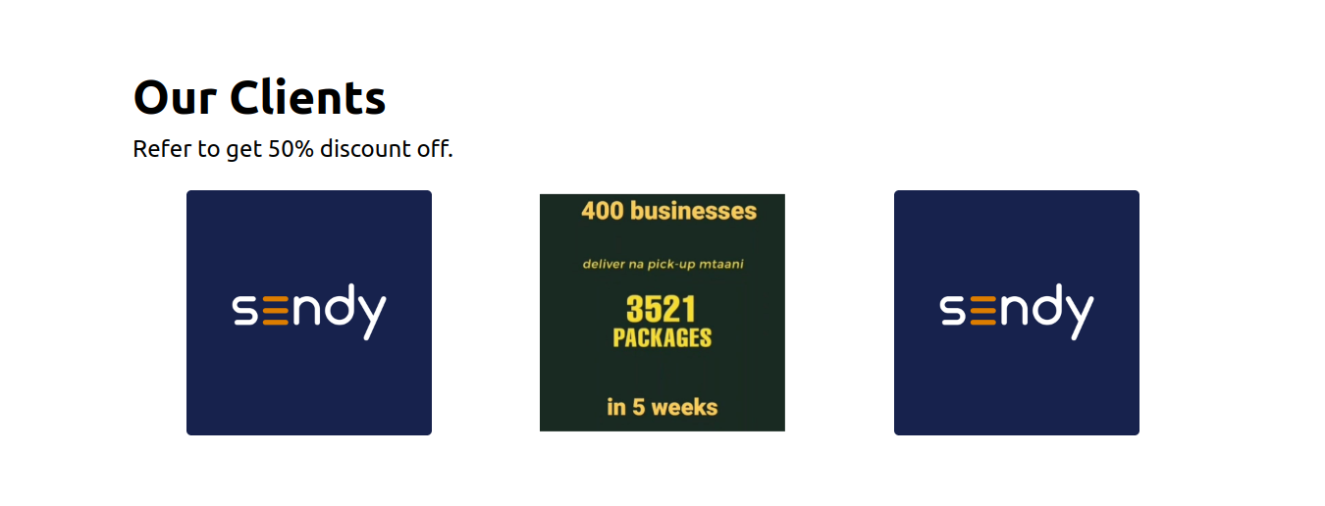

Figure 4

This ensures that the software receives a smooth landing from various of its client without any friction during the initial stages of the software launch.

# Legal and Ethical Issues

The software development business has a lot of fields related to each other. These fields are mobile development, software development and desktop development. There are majority of unethical issues that can happen during and after the software development process. These issues can be highlighted as follows. Data protection faces a lot of legal issues. A user’s data needs to be protected at all costs. Sensitive user data include credit card information, emails, passwords and phone numbers. The website has to also be copyrighted. This means that the code and all the information present in the website page has to be authentic and not outsourced.

# REFENCES

1. How to Use the Seven Principles of Influence for more conversions, Erick Smolin July 2020. <https://postclick.com/blog/principles-of-influence/>
2. Cialdin’s 6 principle of Persuasion World of Work Project, 2019. <https://worldofwork.io/2019/07/cialdinis-6-principles-of-persuasion/>
3. The 6 Principles of Influence by Robert Cialdini BIGJUMP, 2017 <https://www.bigjump.com.au/wp-content/uploads/2017/06/The-6-Principles-of-Influence-by-Robert-Cialdini.pdf>
4. Dr Robert Cialdini and 6 Principles of Persuasion, Tom Polanski 2017, <https://jacobmcmillen.com/wp-content/uploads/2017/01/E_Brand_principles.pdf>

**Appendix 1**



**Appendix 2**



**Appendix 3**



**Appendix 4**



**Appendix 5**



**Appendix 6**

